Resource File Loading Optimization with Combination

*Issue:*

When the first time to login Drug List, the browser will load resource files such as CSS and JS files. For each resource file, a request will be sent to the server. If there are a lot of resource files on the page, it will slow down because the server should handle each request and the client browser has to wait for it. Meanwhile, a lot of HTTP requests for resource files also impose more pressure on the server.

*Solution:*

We utilized omnifaces, a JSF utilities library to combine all CSS files to one CSS file and all JS files to one JS file, which reduces the number of requests from the client browser obviously when login the page at the first time.

*Test Result:*

1. The time to load CSS and JS files without resource combination when first login to Drug List. The home page of Drug List has a total number of 10 CSS and JS files, so there are 10 requests to the server for these files.

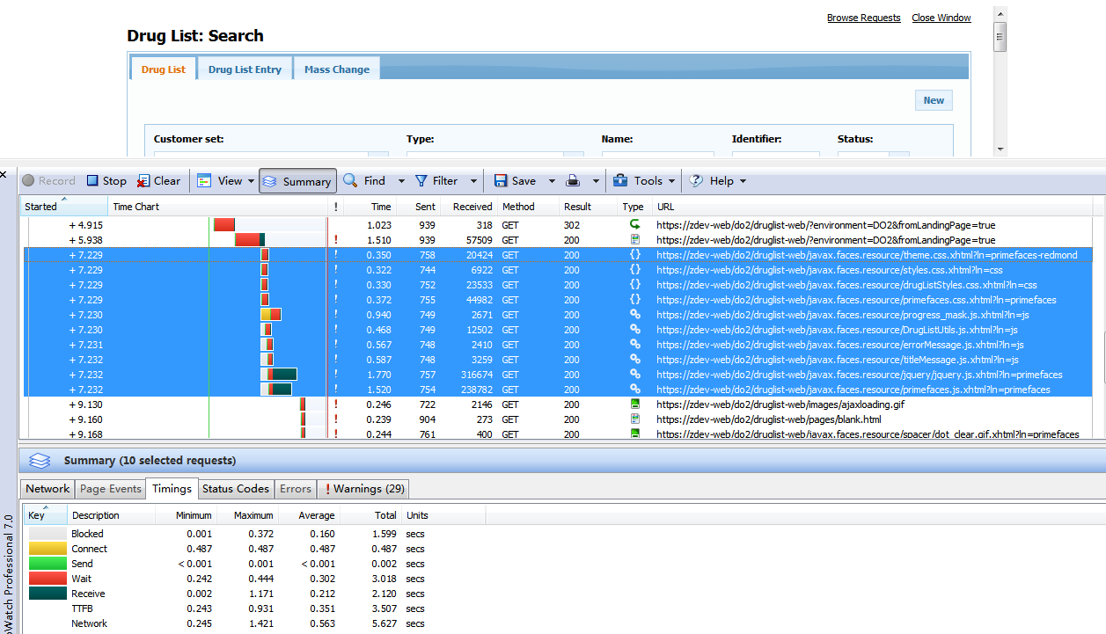

|  |  |  |  |
| --- | --- | --- | --- |
|  | Wait Time | Receive Time | Total Time |
| 1 | 2.865 | 2.005 | 4.87 |
| 2 | 3.715 | 2.689 | 6.404 |
| 3 | 2.788 | 2.712 | 5.5 |
| 4 | 2.64 | 2.217 | 4.857 |
| 5 | 3.801 | 2.493 | 6.294 |
| 6 | 2.746 | 2.511 | 5.257 |
| 7 | 3.034 | 2.754 | 5.788 |
| 8 | 2.994 | 3.142 | 6.136 |
| 9 | 2.785 | 1.763 | 4.548 |
| 10 | 2.702 | 2.272 | 4.974 |
| AVG | 3.007 | 2.4558 | 5.4628 |

1. The time to load CSS and JS files with resource combination when first login to Drug List. All CSS files combined to one JS file, and all CSS files combined to one CSS file. So there are just two request for JS and CSS resource files.

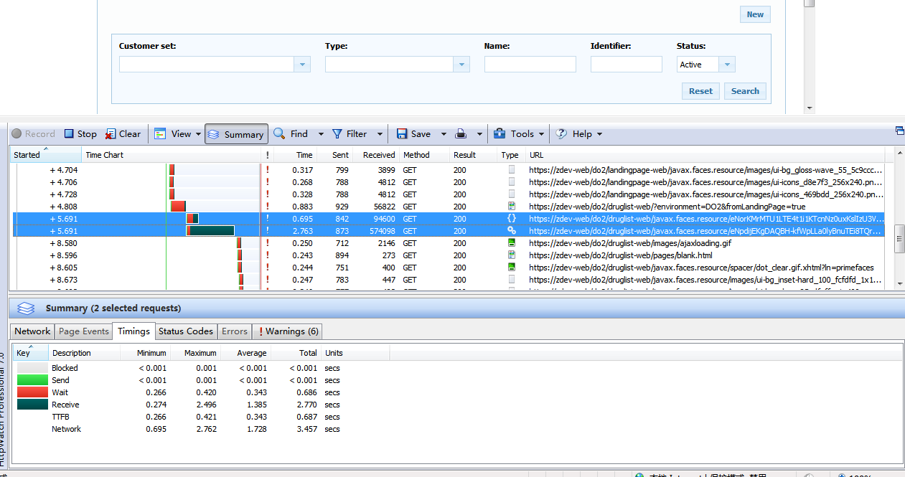

|  |  |  |  |
| --- | --- | --- | --- |
|  | Wait Time | Receive Time | Total Time |
| 1 | 0.64 | 2.884 | 3.524 |
| 2 | 0.64 | 2.916 | 3.556 |
| 3 | 0.762 | 2.702 | 3.464 |
| 4 | 0.63 | 3.136 | 3.766 |
| 5 | 0.603 | 3.125 | 3.728 |
| 6 | 0.66 | 2.657 | 3.317 |
| 7 | 0.674 | 2.709 | 3.383 |
| 8 | 0.703 | 2.672 | 3.375 |
| 9 | 0.648 | 2.676 | 3.324 |
| 10 | 0.686 | 2.77 | 3.456 |
| AVG | 0.665,  reduced by 78% | 2.8247 | 3.4893,  reduced by 36.2% |